ECOVIB2D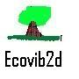

(http://ecovib2d.blogspot.com.au)

BAS Items

Quarter:

Items:

Repairs:

Phone:

Sales:

Hardware:

Internet:

Software:

Stationery:

Electricity:

Home Ins:

Advertising: